Johnny**09/09/2019**

Alright, I'm gonna study a bit tonight and I might do a quick outline of the Feasibility report if no body has started It yet.

Thomas**09/09/2019**

Sounds good

We can probably reuse a lot of their documentation

Johnny**09/09/2019**

True that

Johnny**09/09/2019**

Alright I sent you all an email with the outline so far. We can work on it more tomorrow if you all want.

September 10, 2019

Thomas**09/10/2019**

<https://drive.google.com/drive/folders/1blYblnike1xZaxTloFW_y36d0gM3nS2I?usp=sharing>

[Meet Google Drive – One place for all your files](https://drive.google.com/drive/folders/1blYblnike1xZaxTloFW_y36d0gM3nS2I?usp=sharing)

Google Drive is a free way to keep your files backed up and easy to reach from any phone, tablet, or computer. Start with 15GB of Google storage – free.

September 11, 2019

Thomas**09/11/2019**

I am down for Tuesday for meeting with professor

Johnny**09/11/2019**

Me too!

September 14, 2019

Thomas**09/14/2019**

Native Script is taking a minute to get going so definitely look at it sooner than later

Thomas**09/14/2019**

The Livesync feature is really cool

[](https://cdn.discordapp.com/attachments/619679717905399818/622484931364257793/image0.png)

Johnny**09/14/2019**

Are you going through a tutorial or just going in?

Thomas**09/14/2019**

i was using their tutorial but i kind of went off the rails seeing i was having trouble running the project locally

which i think i finally have working

mobile development is dooty

Thomas**09/14/2019**

quite a bit of a pain but it is running locally

[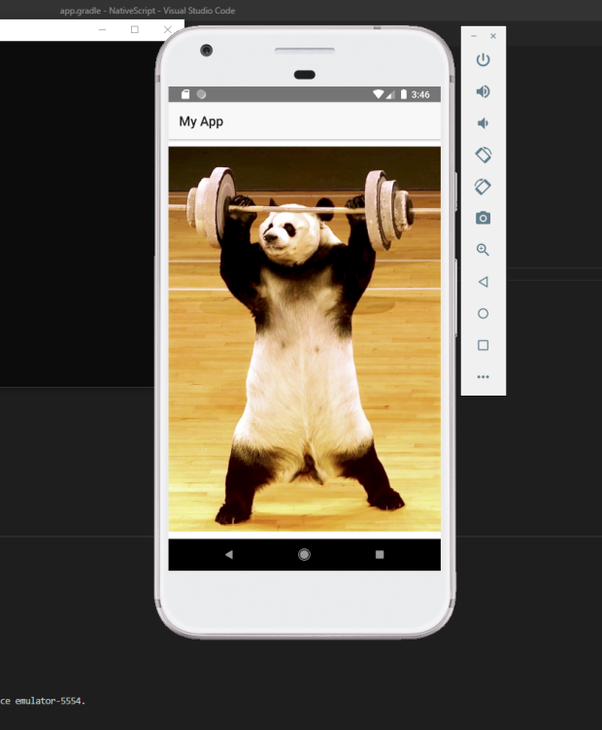](https://cdn.discordapp.com/attachments/619679717905399818/622518522232176640/unknown.png)

Johnny**09/14/2019**

Alrighty, I'll give it a go tonight then!

Know a good tutorial

Thomas**09/14/2019**

<https://docs.nativescript.org/start/ns-setup-win>

[NativeScript Advanced Setup — Windows - NativeScript Docs](https://docs.nativescript.org/start/ns-setup-win)

Follow this walkthrough to learn how to install the NativeScript requirements in order to start creating, developing and building mobile apps on Windows.

ignore step 7 and install android studio and use its emulator

also when you go to create the app just use

tns create

and select the angular option.

i can hop in the voice chat tonight too. i was planning on just playing around with it.

September 16, 2019

Johnny**09/16/2019**

Hey so when should we submit the feasibility report. Cause it's due tomorrow. Also there is a few things that need to be added here and there...

Hannah**09/16/2019**

We can look over it tomorrow after our meeting with dr Taylor and add whatever needs to be added. No ones transferred stuff over from the previous feasibility report yet right?

Johnny**09/16/2019**

Sounds good! And I havent.

Thomas**09/16/2019**

I believe in you(edited)

Hannah**09/16/2019**

Dr Taylor just emailed me and asked if we could move our meeting to Thursday instead. Is that okay with you guys?

Thomas**09/16/2019**

fine with me

Johnny**09/16/2019**

Good with me

What time?

Hannah**09/16/2019**

After algorithms so at 3

September 17, 2019

Thomas**09/17/2019**

<https://drive.google.com/drive/folders/1blYblnike1xZaxTloFW_y36d0gM3nS2I?usp=sharing>

[Meet Google Drive – One place for all your files](https://drive.google.com/drive/folders/1blYblnike1xZaxTloFW_y36d0gM3nS2I?usp=sharing)

Google Drive is a free way to keep your files backed up and easy to reach from any phone, tablet, or computer. Start with 15GB of Google storage – free.

Thomas**09/10/2019**

<https://www.nativescript.org/nativescript-is-how-you-build-native-mobile-apps-with-angular>

NativeScript.org

[Build Truly Native Mobile Apps with Angular | NativeScript](https://www.nativescript.org/nativescript-is-how-you-build-native-mobile-apps-with-angular)

this looks like it might make life eaasy

September 12, 2019

Hannah**09/12/2019**

The Github project: <https://github.com/powerfireturbo/FloraLinks> to an external site. Consortium of Midwest Herbaria : <http://midwestherbaria.org/portal/Links> to an external site. -There is a tool here that used to scrape the checklist ( <http://midwestherbaria.org/portal/checklists/dynamicmap.php?interface=checklistLinks> to an external site. ) - You have to put a pin in the map and put in a distance, and it will return a check list with attributes. iDigBio: <https://www.idigbio.org/Links> to an external site. -I used their search API for the geolocation queries. iDigBio Github Serch API wiki: <https://github.com/iDigBio/idigbio-search-api/wikiLinks> to an external site. Encyclopedia of Life: <https://eol.org/Links> to an external site. - There is a LOT of good info that would be helpful here, but I couldn't find a good way to get it on the fly from the app. If you do a remote database, you might be able to use some of the stuff here. They do have an API, but your key is associated with a single account, and has some pretty restrictive limitations.

September 14, 2019

Thomas**09/14/2019**

<https://ionicframework.com/>

Ionic Framework

[Ionic - Cross-Platform Mobile App Development](https://ionicframework.com/)

Ionic is the app development platform for web developers. Build amazing cross platform mobile, web, and desktop apps all with one shared code base and open web standards

this was also recommended by my boss

Thomas**09/14/2019**

<https://www.youtube.com/watch?v=DcCSq2Y9bow>

[YouTube](https://www.youtube.com/)

[Academind](https://www.youtube.com/channel/UCSJbGtTlrDami-tDGPUV9-w)

[NativeScript Tutorial for Beginners - Build iOS, Android and Web A...](https://www.youtube.com/watch?v=DcCSq2Y9bow)

Johnny**09/14/2019**

Yeah I saw that one, but first I'm doing an angular tutorial lol

Im almost done with the angular tutorial now

Thomas**09/14/2019**

that is fair. i had some issues setting up the angular cli for native script but once i got that working it has made life easier

Johnny**09/14/2019**

It's a basic one lol

Thomas**09/14/2019**

good its a good tutorial but angular is really weird

oh tour of heros is the best one

Thomas**09/10/2019**

<https://angular.io/tutorial>